 [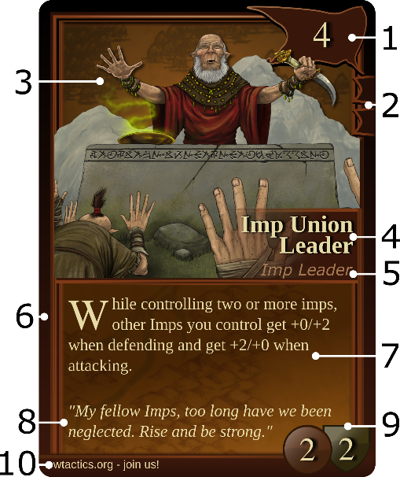](https://arcmage.org/wiki/index.php?title=File:Cardlayout.png)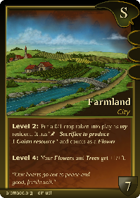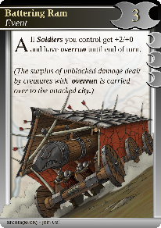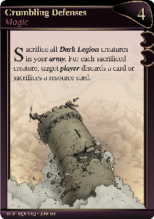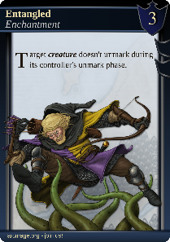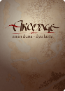

***Cities*** are built by skipping your turn; they provide strategic advantages.

***Events*** can be played at any time, even during an opponent’s turn.

***Magic*** spells are more powerful and can only be played during your play phase.

***Enchantments*** are permanent spells attached to their target and can only be played during your play phase.

***Creatures*** are always cast into a city where they become a resident. A creature can move to the army or another city during your play phase.

Many creatures have special skills or *abilities* and may or may not require **marking ( )** to trigger them.   
The abilities are explained on the card, and there is an extensive list of abilities available online.

Creature / Red Banner

1. **Faction Logo & Cost**
2. **Loyalty Marks**
3. **Card Art**
4. **Card Name**
5. **Card Type**
6. **Colored Border**
7. **Card Text**
8. **Flavor Text**
9. **Combat Statistics**
10. **Footer**

**Introduction**

***Arcmage*** is a turn-based strategic card game, in which players battle each other with *magic* spells, *events, creatures* and *enchantments*.

A player is defeated when all their cities are destroyed. Be the last arcmage standing to win the game!

Each player selects one of the pre-constructed decks or builds thier own deck of 45 cards.

**Getting Started**

1. Randomly decide who starts.
2. Take out three city cards from your deck.
3. Shuffle the rest of the deck.
4. Draw 7 cards.
5. Build your first city by putting it face up.
6. You're ready to go to battle!

Check out the full rule set at: arcmage.org/rules

**Turn Structure**

A player’s turn consists of the following phases:

1. **Unmark**
2. **Draw & Resources**
3. **Tactics** *(optional)*
4. **Play** *(optional)*
5. **Attack** *(optional)*
6. **Play** *(optional)*
7. **Discard**

Each card has a card *type* and belongs to a specific *faction:*

**Factions & Card Types**

**Battlefield Setup**

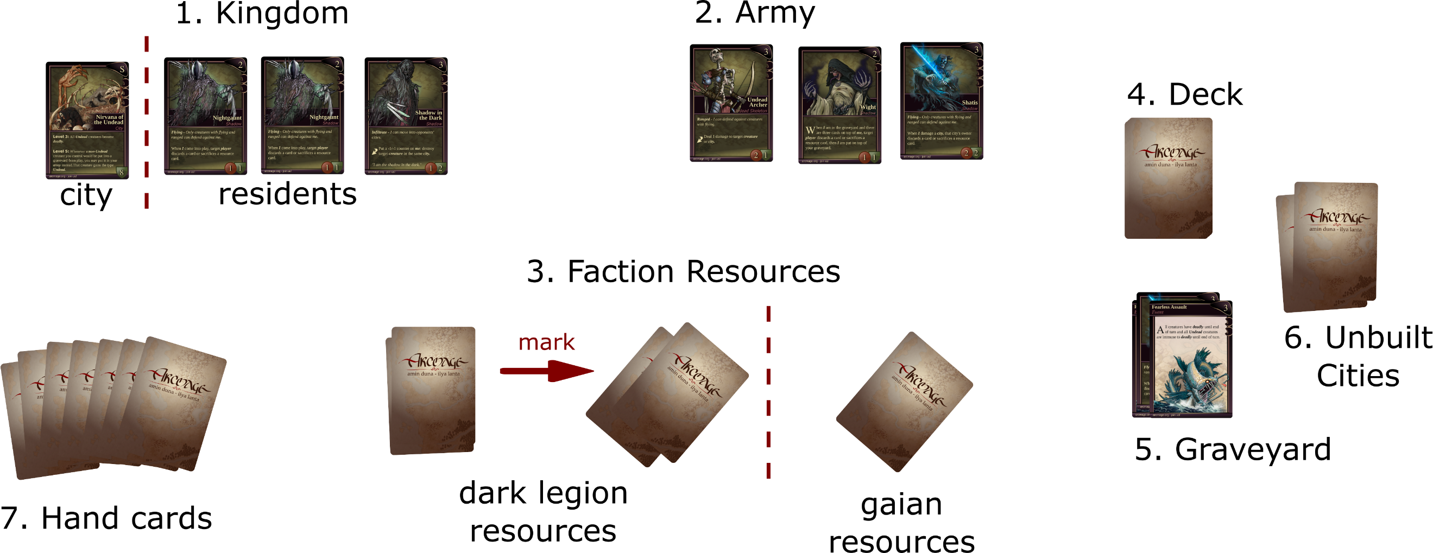

Event /

The Empire

Magic /

Dark Legion

City /

Gaian

Enchantment /

House of Nobles

### Kingdom (1)

When you build a city, you place it in your Kingdom area. When creatures visit the city, they become residents of that city. Cities are peaceful places, so residents of a city cannot launch attacks, but they defend their city bravely when attacked.

### Your Army (2)

Creatures that will help launch an *attack* or *defend* against enemy attacks must be in your *Army* area, face up.

### Faction Resources (3)

Each faction in your deck has its own vault of resource cards. Resource cards are needed to play spells and creatures.

### Deck (4)

This area is where the deck resides and from where you *draw* new cards every time it is your turn.

### Graveyard (5)

The area where *all* the *discarded*, *used up*, *wasted* or *killed* cards go. These might be, for instance, dead creatures, used events or magic cards.

### Unbuilt Cities (6)

The area where your remaining unbuilt cities lay dormant. Skip your turn to place one of these in your kingdom.

### Hand (7)

Not really an area; these cards you hold in your hand.

1. **Unmark**

A card that is in use is placed in landscape position (***marked***). Putting it back in portrait is called ***unmarking***.

During the unmark phase, ***unmark*** all your marked cards.

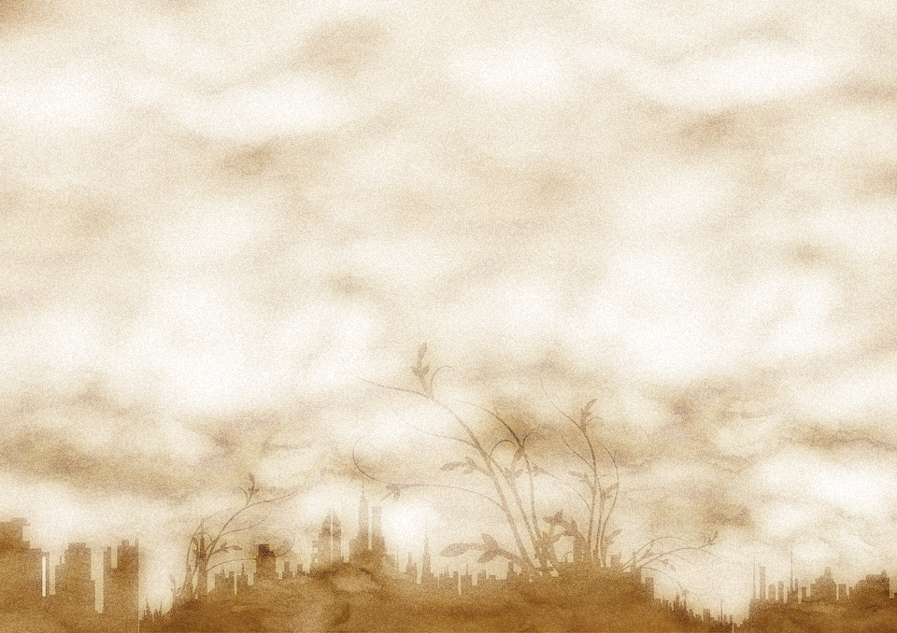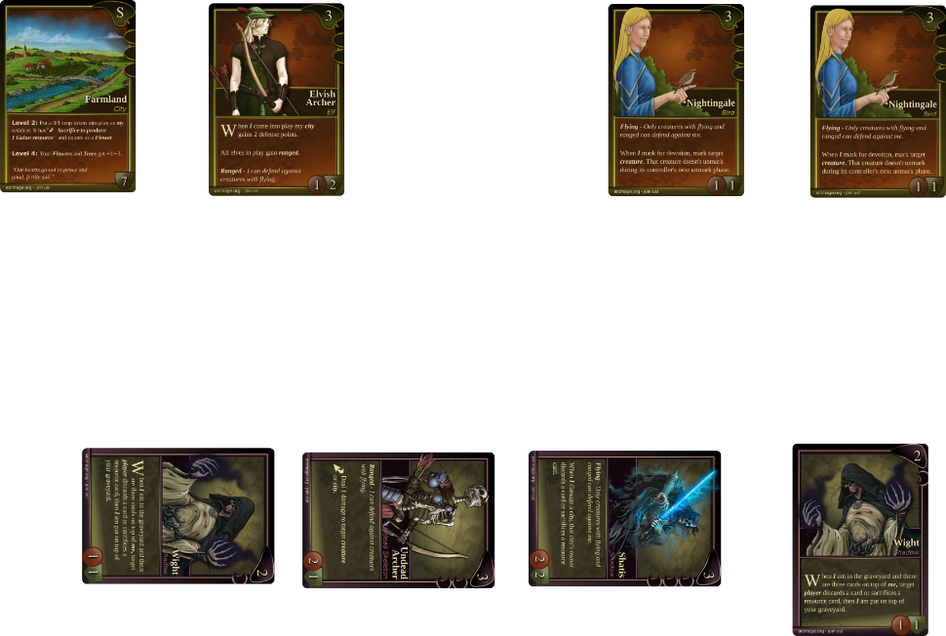

**2. Draw & Resources**

During the draw phase, the player must take 1 of 3 possible courses of action:

***draw 2 cards***, and play no resource cards,

***draw 1 card,*** and play 1 resource card (optional),

***draw 0 cards***, and play 2 resource cards (not an option if the player can't play the 2 resource cards)

If the player has no cards in hand, they **must** draw at least one card. The player draws all cards at once, then plays the resource cards.

**To play a resource card,** select an unwanted card from your hand and put it face down into a faction’s resource pile of your choice.

**3. Tactics (optional)**

When a city reaches a certain level of devoted *residents*, it provides a tactical advantage. ***Mark*** any number of *residents* to indicate their devotion to the city.

The city's devotion is the sum of all loyalty marks given by all devoted residents.

For each city level reached, the advantage is triggered (mandatory). They are resolved in order, lowest levels first.

* An advantage can be a one-time action, or have a permanent effect.
* The devotion must be renewed every turn.

In the play phase, a player may cast enchantments or magic spells and play creatures into a city. To play a card, look at its cost and loyalty marks.

**4 & 6. Play (optional)**

***1. Cost***: To play this card, you’ll have  
 to ***mark*** a total of 4 ***resource cards***

***2. Loyalty marks:*** Indicate how  
 many of the cost’s resource cards   
 must be paid using the faction's   
 own resources. The remainder of   
the resource cost can be paid using any kind of resources.

**5. Attack (optional)**

During the attack phase, the player may select creatures from their army to attack a single opponent's city. See ***Combat***.

Additionally, in order to play a card preconditions may apply, which appear in the card's rule text.

Furthermore, in the play phase, a player may *activate abilities* or *move* creatures in or out of the city.

To ***move*** a creature, ***mark*** it and place it in the target city or army. A single city can only once   
per turn be the source or destination of a move operation.

**Events**

Any player may play an event card at *any time*, even during an opponent's turn.

When an *event* card is played, its effects are not taken into account immediately; the opponent is given the chance to react and play an *event* card in response.

### Order of Resolution

* When an *event* card is played, it is placed on an imaginary stack. Its effects are   
  not yet taken into account.
* All players (including the originating player) have the opportunity to play an *event* card in response; it is placed on top of the imaginary stack. Its effects are not yet taken into account.
* This action-reaction process is repeated until all players stop playing additional *event* cards.
* The top card on the imaginary stack is now resolved, and its effects occur.
* New event cards can be played, and put on the stack, and the new top card is resolved, etc...

**In short, the last played card's effect is applied first and, at any time, new *event* cards can be played.**

**7. Discard**

At the end of your turn, discard cards from your hand to the graveyard until 7 cards remain.

**-- the Arcmage team**

* Defending doesn’t require marking.
* Both the city’s residents and the opposing army creatures can intercept. It is up to the defending player to choose.
* Multiple defenders against a single attacker are allowed.
* Attackers that are not intercepted damage the attacked city;  
  its defense strength is permanently lowered.
* When a city’s defense strength is **zero or less,** it is **destroyed**. Unmarked residents *move* to another city; marked residents return to their owner’s hand.
* Lose all of your cities and you’re out of the game.

Each battle between an attacking creature and its defenders is fought separately.

* The attacker distributes his attacking strength (red circle) among the defenders.
* If the defending strength (green shield) is lower, the defender dies, although not before it strikes back. Hence, both the attacker and the defenders can die at the same time. Any attached enchantments are discarded.

When a creature survives the battle, it is healed at the end of the turn.

**We hope you’ll enjoy the game,**

**Combat**

**full credits at arcmage.org/credits**

**arcmage.org - join us!**

**Arcmage is licensed under a Creative Commons Attribution-ShareAlike 4.0 International License.**

**2. attack   
target city**

**Opponent’s city**

**City residents**

**Opponent’s army**

**1. your army: mark creatures to attack**

**3. opponent intercepts to defend against attacking creatures**